
NASTP Institute of Information Technology
Department of Artificial Intelligence
ReSched AI
University Timetable Optimizer
Submitted By: Umar Ali S2025AI002
Team Members: Sohaib S2025AI018 Huzaifa S2025AI036
Submitted To: Dr. Ali Arshad
Semester: III
Session: Spring 2025 to 2029
Subject: AI Theory
Date of Submission: 24/05/2026

1. Project Overview
ReSched AI is a web-based university timetable optimizer designed for NIIT-style academic scheduling. The system is built to solve a practical timetable problem where faculty availability, rooms, labs, credit/contact hours, section loads, and repeat-student clashes must be considered together. The project uses artificial intelligence concepts through constraint satisfaction, backtracking search, heuristic ordering, soft-constraint scoring, and explainable decision output.
Project Title | ReSched AI: Repeat-Student Aware University Timetable Optimizer
Main Objective | Generate conflict-free and fair university timetables with clear scheduling explanations.
AI Approach | Constraint Satisfaction Problem with DFS/backtracking and heuristic scoring.
Expected Output | Section-wise timetable, teacher/room/lab views, quality score, conflict report, and PDF exports.

2. Problem Definition
Manual timetable preparation becomes difficult when the same teacher teaches multiple sections, lab rooms are limited, courses have different contact-hour rules, and some students may repeat courses from another semester. A normal timetable may avoid basic room clashes but still leave students with long gaps, late releases, repeated-course conflicts, and no explanation for why a slot was selected. ReSched AI addresses these issues as a decision-making problem rather than a static timetable display.
- Teachers must not be assigned to two classes at the same time.
- Rooms and labs must not be double-booked.
- Labs must be continuous blocks and must use lab rooms.
- Theory courses must respect credit-hour patterns such as 3-credit 2+1 weekly split.
- Schedules should reduce unnecessary waiting time and produce an explanation for each class.

3. Background Study
University timetabling is commonly treated as a Constraint Satisfaction Problem and optimization problem. Existing systems often handle teacher, room, and section clashes. Some open-source projects also use backtracking or genetic algorithms. The gap selected for this project is practical academic fairness: repeat-student protection, compact section schedules, day fairness, fixed teacher-course consistency, and visible explanations for scheduling decisions.

4. Objectives and Scope
- Provide an admin dashboard for teachers, courses, sections, rooms/labs, time slots, and section subject plans.
- Import NIIT SECTION-WISE document data and convert it into structured scheduling records.
- Generate valid timetables using hard constraints and improve them with soft optimization.
- Display a conflict report, quality score, and explanation panel for scheduled classes.
- Export complete and section-wise timetables through CSV, PDF, and ZIP outputs.

5. Tools, Libraries, and Technologies
Layer | Technology / Library | Purpose
Frontend | React, Tailwind-style CSS, Lucide icons | Interactive admin dashboard and timetable views
Backend | Python FastAPI | API routes, validation, scheduling calls, exports
Database | SQLite | Local project data storage
Documents/PDF | ReportLab | PDF timetable and per-section ZIP export
Data Processing | Python standard libraries, DOCX extraction logic | SECTION-WISE import and cleanup
AI Engine | Custom Python CSP/backtracking/heuristic modules | Generate and score timetable assignments

6. Dataset and Input Module
The project uses the provided SECTION-WISE files as the main academic dataset. These files were extracted into structured records for sections, courses, faculty, rooms/labs, contact hours, and existing section plans. Semester-total rows and inconsistent lab-hour rows were cleaned so the scheduler receives real class sessions only.
Programs | CS, AI, CYS, SE
Sections | 12
Courses | 52
Teachers | 37
Rooms/Labs | 15
Weekly Sessions Generated | 149
Academic Timing | 09:00 AM to 04:30 PM

7. System Design
The system separates the user interface, API, database, and AI scheduling logic. This keeps the project modular and makes it easier to test each part independently.
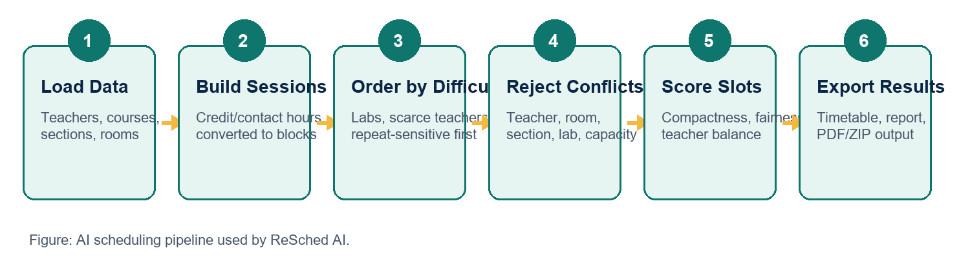
Figure 1: High-level scheduling flow used by ReSched AI.

8. AI Method and Logic
ReSched AI models timetable generation as a CSP. Each class session is a variable. Available time slots, teachers, and rooms form candidate domains. Hard constraints reject invalid candidates, while the scoring function ranks valid options.
CSP | Models teachers, rooms, sections, labs, time slots, and repeat-student constraints.
DFS / Backtracking | Attempts assignments and can recover when later choices become impossible.
Heuristic Ordering | Schedules labs, scarce teachers, longer sessions, and repeat-sensitive sessions earlier.
Soft Optimization | Improves valid schedules for compactness, early release, fairness, and workload balance.
Explainable AI | Stores reasons for selected slots so the user can understand each decision.
Adaptive Profile | Updates scoring weights after generation based on weaker quality areas.

9. Constraint Rules
The scheduler uses hard constraints for rules that must never break and soft constraints for quality improvements.
Rule Type | Examples | Reason
Hard | Teacher, room, section clash prevention | Timetable is invalid if these break.
Hard | Lab courses in labs; theory in classrooms | Protects academic delivery requirements.
Hard | 3-credit theory split as 2+1 on separate days | Matches realistic weekly contact-hour pattern.
Hard | Labs as one continuous 3-hour block | Prevents broken lab sessions.
Hard | Same teacher for same section-course all week | Keeps course responsibility consistent.
Soft | Compact timetable and early release | Improves student experience.
Soft | Teacher workload balance and day fairness | Improves fairness when multiple valid solutions exist.
Soft | Difficult courses earlier where possible | Improves academic usability without blocking valid schedules.

10. Implementation Modules
- Input Module: admin dashboard, SECTION-WISE importer, entity forms, section subject plan, and teacher availability matrix.
- Processing / AI Logic Module: scheduler, constraint checker, slot scoring function, and explanation generator.
- Output Module: timetable grid, teacher/room/lab views, conflict report, quality score, CSV, PDF, and ZIP exports.
- Error Handling: invalid login checks, missing import folder checks, API error responses, unscheduled-session reporting, and export guards.

11. Code Organization
All project files are kept inside one project folder so the code, dataset, screenshots, and generated outputs can be submitted together. The code is separated by responsibility instead of being written in one large file.
backend/main.py | FastAPI routes, login, generation endpoint, import endpoint, and export endpoints.
backend/scheduler.py | CSP-style scheduling engine, hard-constraint checks, scoring, and explanation generation.
backend/sectionwise_importer.py | Extraction and cleaning of SECTION-WISE DOCX timetable data.
backend/store.py | SQLite-backed dataset loading, saving, and latest-run storage.
static/app.jsx | React user interface for admin pages, timetable views, reports, and export actions.
data/ | SQLite database, extracted JSON/CSV data, and section-wise timetable ZIP output.

12. Testing and Validation
The final run was tested on the imported SECTION-WISE dataset. The system generated every required weekly session and reported no hard conflicts.
Scheduled Sessions | 149 / 149
Unscheduled Sessions | 0
Hard Conflicts | 0
Overall Quality Score | 85 / 100
Hard Constraint Score | 100 / 100
Compactness Score | 96 / 100
Lab Quality Score | 96 / 100
Repeat Protection Score | 100 / 100
- Teacher clashes avoided: 2613
- Room clashes avoided: 7015
- Section clashes avoided: 13780
- Lab allocation conflicts avoided: 400
- Friday prayer break rejections: 2580

13. Results and Screenshots
The following screenshots show the working implementation and outputs.
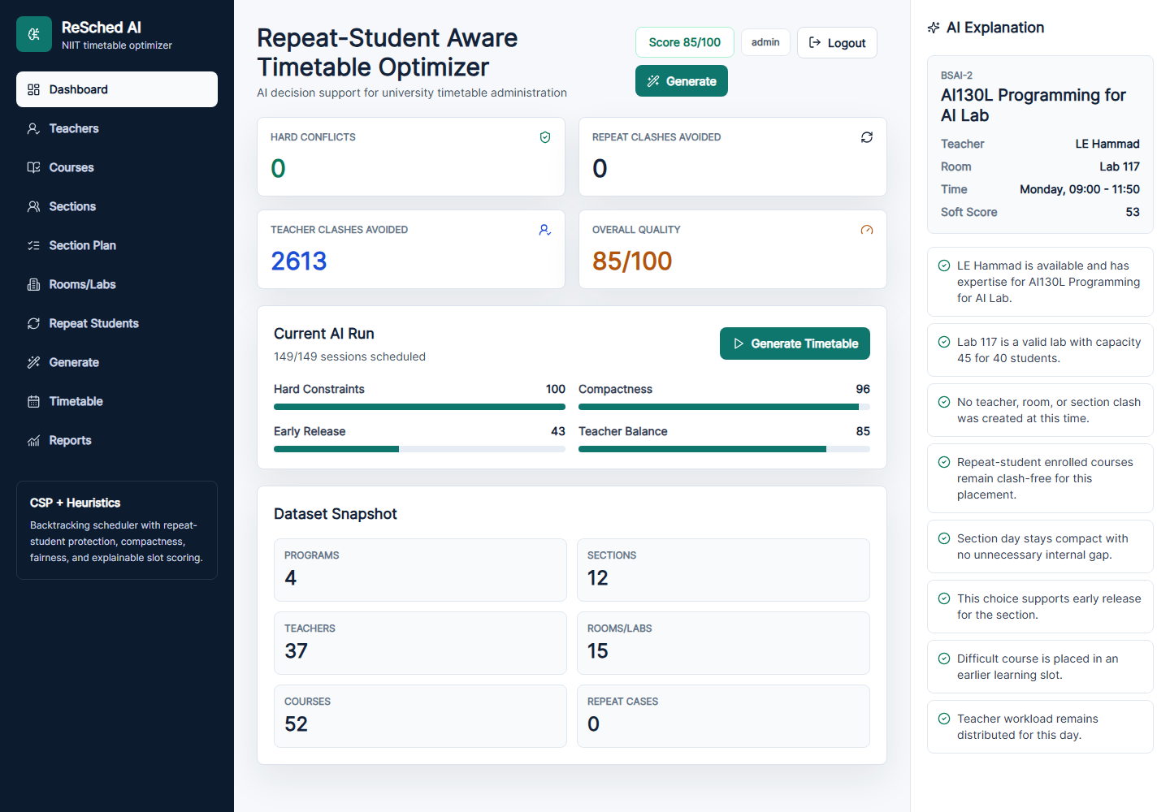
Figure 2: Dashboard with conflict count, quality score, AI health, and dataset snapshot.
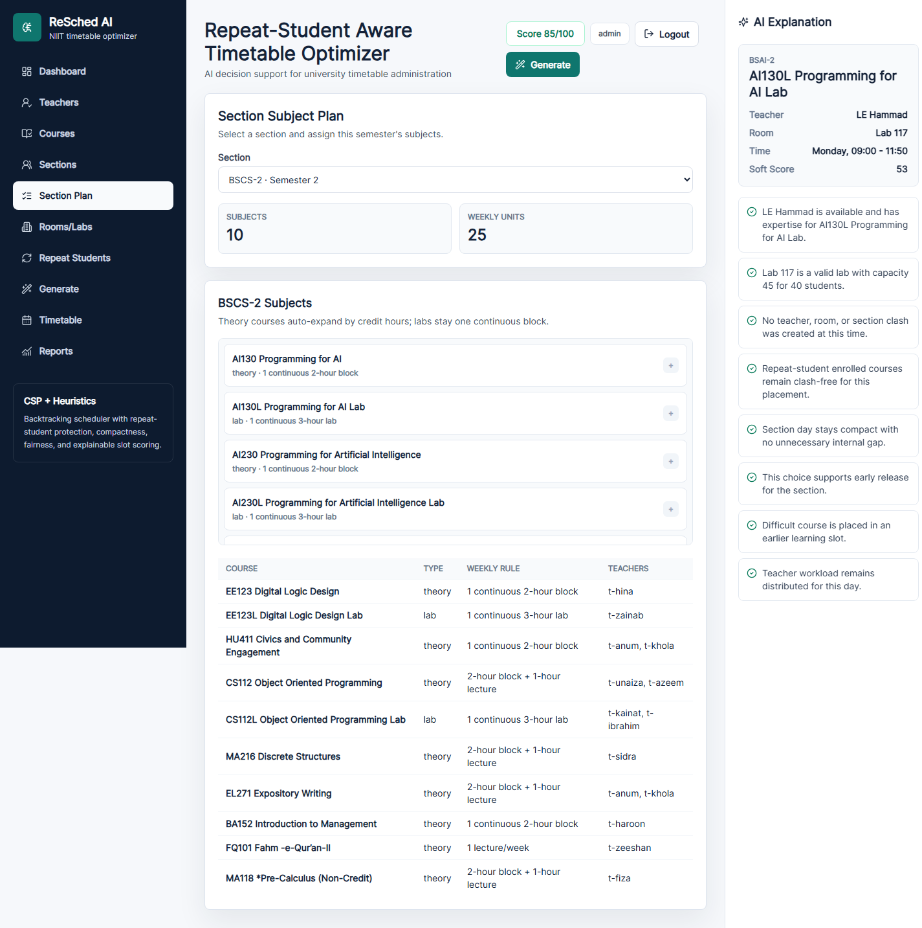
Figure 3: Section Subject Plan showing which section studies which courses in the semester.
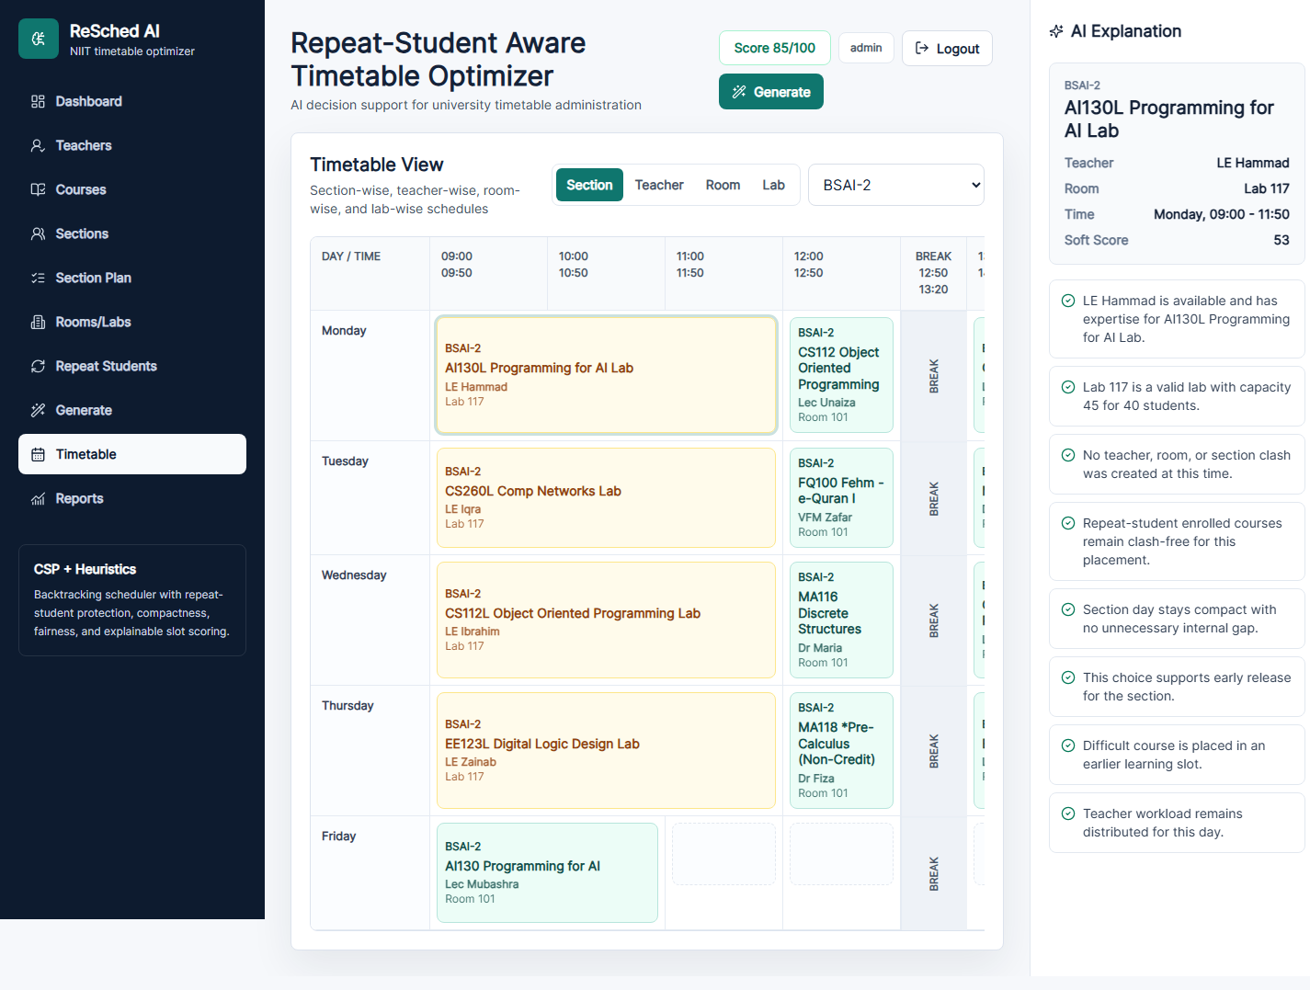
Figure 4: Section-wise timetable view with AI explanation panel.
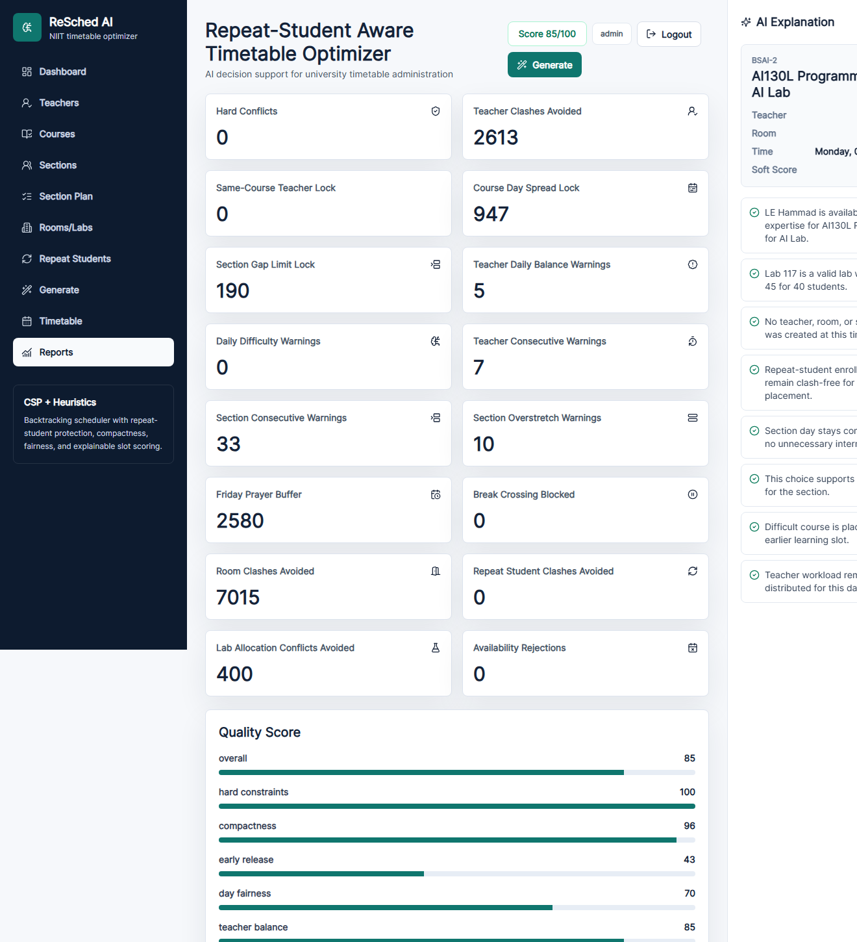
Figure 5: Reports page showing constraints, AI concepts, quality metrics, and validation output.
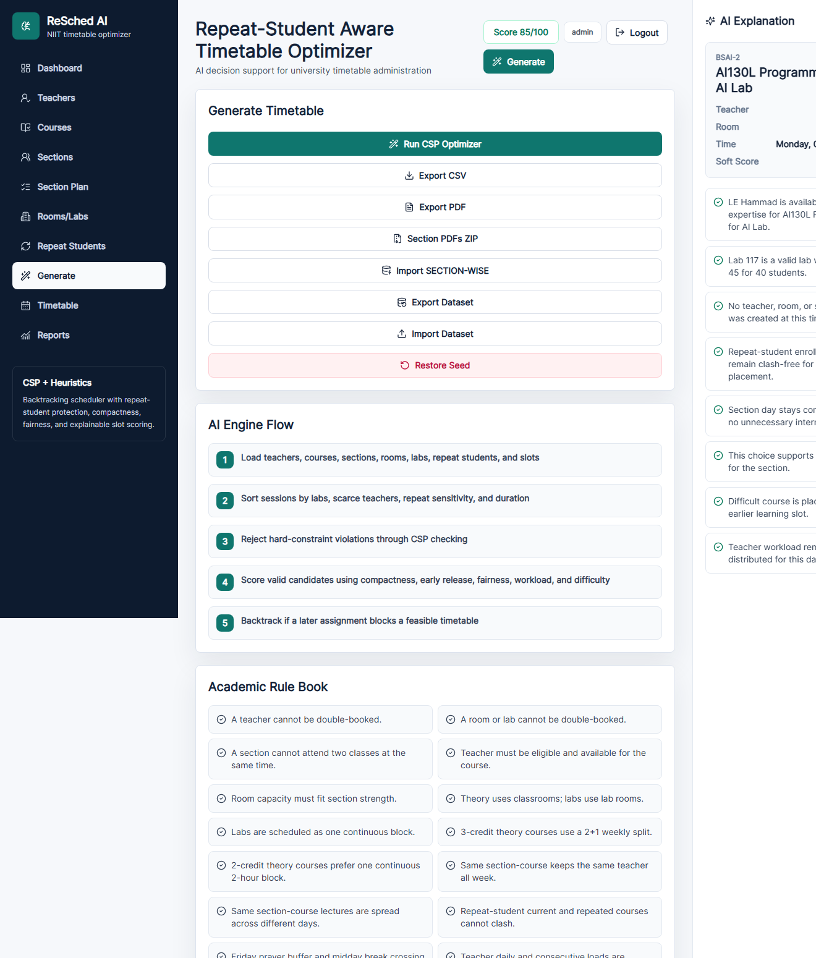
Figure 6: Generate/export page with academic rules, export options, and latest run status.

14. Challenges and Solutions
Challenge | Solution Implemented
Lab sessions appeared as repeated cells. | Rendered multi-slot lab entries as one continuous merged block.
Some imported rows were semester-total text, not courses. | Importer filters non-course rows before seeding data.
Lab contact hours could be read incorrectly. | Importer and scheduler force lab duration to continuous 3-hour blocks.
Same course could be assigned different teachers in one section. | Added section-specific teacher consistency rule.
A fully imported dataset can become impossible if all quality rules are hard. | Kept essential clashes hard and treated fairness/workload as scored soft constraints.
PDF output could overflow page boundaries. | Added compact section-wise layouts and ZIP export for separate section PDFs.

15. Limitations and Future Work
The current version is suitable for a CCP demonstration and local academic scheduling workflow. Some features are intentionally kept for future extension.
- Connect directly with NIIT AMS database after official API/database access is available.
- Import exact student enrollment and repeat-student records automatically.
- Add drag-and-drop manual timetable changes with instant revalidation.
- Add multiple optimizer modes such as genetic algorithm or simulated annealing for comparison.
- Add role-based access for department heads, faculty, and timetable coordinators.

16. Conclusion
ReSched AI demonstrates how AI problem-solving can be applied to a real university administration problem. The system models timetabling as a CSP, uses backtracking and heuristic search to find valid assignments, optimizes the result through soft scoring, and explains the reasoning behind each scheduled class. The final test run scheduled all 149 sessions with zero hard conflicts, showing that the design meets the core requirements of the AI CCP project.

